Objectives:

* Creating Arrays + Tkinter

**There are 4 projects, each is worth 25%.**

**Project #1:** write the following program and get the output in a console and a text file.

**#1 Print screen the output with the code below here.**

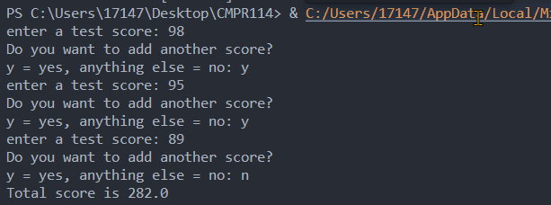

Code:

def get_score():

#Create empty list

test_scores = []

again = 'y'

while again == 'y':

value = float(input("Enter a test score: "))

test_scores.append(value)

print("Do you want to add another score?")

again = input("y = yes, anything else = no: ")

return test_scores

def get_total(value_list):

total = 0.0

for num in value_list:

total += num

return total

def main():

scores = get_score()

totalval = get_total(scores)

#Display results in console

msg = f"Total score is {totalval}\n"

print(msg)

#Write to file

file = open("C:\\Users\\17147\\Desktop\\CMPR114\\m4\\Results.txt", "w")

file.write(msg)

file.close

if __name__ == "__main__":

main()

**Project #2:** complete the following program below.

*Note: do not enter* ***20*** *numbers, enter* ***5*** *numbers instead.*

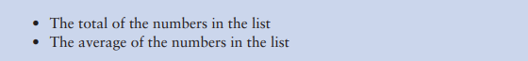

**#2 Print screen the output with the code below here.**

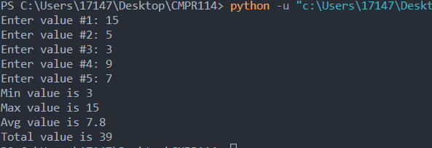

Code:

listval=[]

totalval = 0

MAX_RANGE = 5

for i in range(1,MAX_RANGE+1):

val = int(input(f"Enter value #{i}: "))

listval.append(val)

totalval += val

avgval = totalval / MAX_RANGE

minval = min(listval)

maxval = max(listval)

print(f"Min value is {minval}")

print(f"Max value is {maxval}")

print(f"Avg value is {avgval}")

print(f"Total value is {totalval}")

**Project #3:** complete the following program below. Research the most popular names on the Internet or just make up some names.

Create two files and enter up to 5 girls’ and boys’ names. The first file will have 5 girls’ names and the second file will have 5 boys’ names.

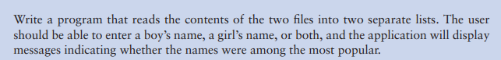

**#3 Print screen the output with the code below here.**

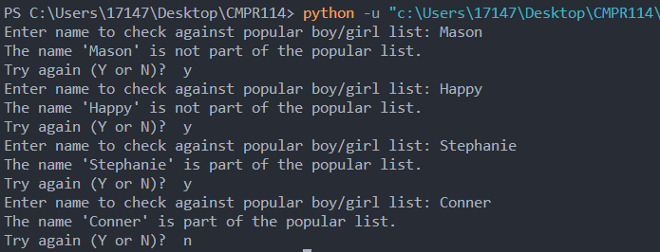

Code:

def read_boy_names():

with open("C:\\Users\\17147\\Desktop\\CMPR114\\m4\\boysname.txt", "r") as file:

names = [line.rstrip("\n") for line in file]

return names

#Open girls name file

def read_girl_names():

with open("C:\\Users\\17147\\Desktop\\CMPR114\\m4\\girlsname.txt", "r") as file:

names = [line.rstrip("\n") for line in file]

return names

def main():

boys = read_boy_names()

girls = read_girl_names()

loopval = "y"

checkboy = False

checkgirl = False

while loopval == "y":

checkname = input("Enter name to check against popular boy/girl list: ")

#Check if name exists in boys list

if checkname in boys:

checkboy = True

#Check if name exists in girls list

if checkname in girls:

checkgirl = True

if checkboy == True or checkgirl == True:

print(f"The name '{checkname}' is part of the popular list.")

else:

print(f"The name '{checkname}' is not part of the popular list.")

loopval = input("Try again (Y or N)? ").lower()

#Result check flag

if loopval == "y":

checkboy = False

checkgirl = False

if __name__ == "__main__":

main()

**Project #4:** Create a Tkinter GUI application below (See print screen) but add the following 1-4 additions to the application.

1. Name of the student
2. Students’ Student ID
3. Gender of the student (Use 2 Radio Buttons)
4. Output the inputs to a message box and an external file somewhere on your computer.

**#4 Print screen the output with the code below here. Be sure to enter 2 entries, open the text file, and print screen it below here.**

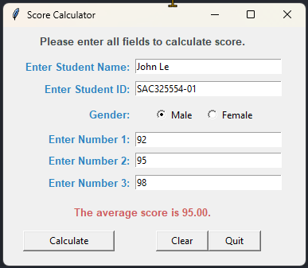

Code:

import tkinter as tk

from tkinter import *

from tkinter import ttk

from tkinter import messagebox

def main ():

def cleartext():

global msg

txtname.delete(0, tk.END)

txtID.delete(0, tk.END)

rbGender.deselect()

txtscore1.delete(0, tk.END)

txtscore2.delete(0, tk.END)

txtscore3.delete(0, tk.END)

displaymsg=""

lblDisplay.config(text=displaymsg)

lblDisplay.grid(column=0, row=7, padx=5, pady=12, columnspan=2)

def quit():

messagebox.showinfo(title="Exit Program", message="Bye!")

win.quit()

win.destroy()

def calculate():

#Calculate total and average

fname = name.get()

studentid = strID.get()

gender_selected = radio_selected.get()

val1 = score1.get()

val2 = score2.get()

val3 = score3.get()

total = int(val1) + int(val2) + int(val3)

avg = total/3

displaymsg = f"The average score is {avg:,.2f}."

lblDisplay.config(text =displaymsg, fg="#CD5C5C")

#lblDisplay.grid(column=0, row=7, ipadx= 5, pady=12, columnspan=2)

#write to file

studentmsg = f"Student Name: {fname}\nStudent ID: {studentid}\nSex: {gender_selected}\n"

resultmsg = f"\nThe three scores are {val1}, {val2}, {val3}.\nThe total is {total}.\nThe average is {avg:,.2f}."

file = open("C:\\Users\\17147\\Desktop\\CMPR114\\m4\\project4.txt", "w")

file.write(studentmsg+resultmsg)

file.close

messagebox.showinfo("Submitted successfully", message=studentmsg+resultmsg)

#Initiliaze windows interface

win = tk.Tk() #Create window interface

win.geometry("380x300") #Set window size (width by height)

win.title("Score Calculator") #Label title for window

# Instruction Label

frm1 = tk.Frame(win)

frm1.grid(column=0, row=0, ipadx=0, padx=0, pady=7, columnspan=2) #Label widge

lblheader = tk.Label(frm1, text = "Please enter all fields to calculate score.", font="Arial 10 bold", fg="#424949", anchor="w")

lblheader.grid()

# Student Input

lblname = tk.Label(win, text = "Enter Student Name: ", font="Arial 10 bold", width=20, anchor="e", fg="#2E86C1")

lblname.grid(column=0, row=1, ipadx = 0, padx = 0, pady=3) #Label widge

name = tk.StringVar() #Manage the Entry widget

txtname = tk.Entry(win, width=30, textvariable=name)

txtname.grid(column=1,row=1, ipadx = 0, padx = 0, pady=3)

txtname.focus_set()

lblID = tk.Label(win, text = "Enter Student ID: ", font="Arial 10 bold", width=20, anchor="e", fg="#2E86C1")

lblID.grid(column=0, row=2, ipadx = 0, padx = 0, pady=3) #Label widge

strID = tk.StringVar() #Manage the Entry widget

txtID = tk.Entry(win, width=30, textvariable=strID)

txtID.grid(column=1,row=2, ipadx = 0, padx = 0, pady=3)

lblGender = tk.Label(win, text = "Gender: ", font="Arial 10 bold", width=20, anchor="e", fg="#2E86C1")

lblGender.grid(column=0, row=3) #Label widge

frm2 = tk.Frame()

frm2.grid(column=1, row=3, ipadx = 0, padx = 0, pady=3, columnspan=2)

gender = ["Male", "Female"]

radio_selected = tk.StringVar()

for index in range(len(gender)):

rbGender = tk.Radiobutton(frm2,

text=gender[index], #add text to radio buttons

value=gender[index],

variable=radio_selected,

anchor="w"

) #assign each radiobutton a different value

rbGender.grid(column=index, row=0, ipadx = 5, padx = 0, pady=3)

# Score Input

lblscore1 = tk.Label(win, text = "Enter Number 1: ", font="Arial 10 bold", width=20, anchor="e", fg="#2E86C1")

lblscore1.grid(column=0, row=4) #Label widge

score1 = tk.StringVar() #Manage the Entry widget

txtscore1 = tk.Entry(win, width=30, textvariable=score1)

txtscore1.grid(column=1, row=4, ipadx = 0, padx = 0, pady=3)

lblscore2 = tk.Label(win, text = "Enter Number 2: ", font="Arial 10 bold", width=20, anchor="e", fg="#2E86C1")

lblscore2.grid(column=0, row=5, ipadx = 0, padx = 0, pady=3) #Label widge

score2 = tk.StringVar() #Manage the Entry widget

txtscore2 = tk.Entry(win, width=30, textvariable=score2)

txtscore2.grid(column=1, row=5, ipadx = 0, padx = 0, pady=3)

lblscore3 = tk.Label(win, text = "Enter Number 3: ", font="Arial 10 bold", width=20, anchor="e", fg="#2E86C1")

lblscore3.grid(column=0, row=6, ipadx = 0, padx = 0, pady=3) #Label widge

score3 = tk.StringVar() #Manage the Entry widget

txtscore3 = tk.Entry(win, width=30, textvariable=score3)

txtscore3.grid(column=1, row=6, ipadx = 0, padx = 0, pady=3)

lblDisplay = tk.Label(win, text="", font="Arial 10 bold", justify="center")

lblDisplay.grid(column=0, row=7, padx=5, pady=12, columnspan=2)

btnCalculate = tk.Button(win, text="Calculate", command=calculate, width=15)

btnCalculate.grid(column=0, row=8, ipadx = 0, padx = 0)

frm3 = tk.Frame(win)

frm3.grid(column=1, row=8, ipadx = 0, padx = 10)

btnClear = tk.Button(frm3, text="Clear", command=cleartext, width=8)

btnClear.grid(column=0, row=0)

btnQuit = tk.Button(frm3, text="Quit", command=quit, width=8)

btnQuit.grid(column=1, row=0)

win.mainloop()

if __name__ == "__main__":

main()

**Submit this document to Module 4 homework.**